Anneka Lenssen

340 words

**Hammad, Mahmoud (1923-1988)**

Mahmoud Hammad, born in Jarabulus, Syria,was among the first Arab artists to adopt the letter forms of the Arabic language as a basis for modern compositions, and his experiments predate the pan-regional 1970s florescence of *horoufiyah* (visual manipulations of the Arabic letter in fine art) by more than a decade. His early Arabic writing paintings, first exhibited in exhibitions in Damascus, Beirut, São Paulo, and Venice in the early 1960s, deconstructed the letters to produce semi-geometric abstract compositions. Hammad would continue to explore Arabic writing for the duration of his subsequent career. His later paintings struck a more studied balance between formal and communicative properties. Coming of age during the Syrian struggle for independence, Hammad played roles of both artist and organiser in Syrian modern arts. He started exhibiting in Damascus as early as 1939, and was a member of Studio Veronese, the country’s first fine arts club. In 1952, he was granted a study fellowship to the Academy of Fine Arts in Rome, finishing in 1956. After returning to Syria, he taught in rural schools, then joined the faculty of the new College of Fine Arts in Damascus in 1960. In the 1970s, he would become Dean, serving until 1981. He died in Damascus, Syria.

**References and further reading**

Ali, Wijdan (1997) *Modern Islamic Art: Development and Continuity*, Gainesville: University Press of Florida. (Contributor’s comment: includes overview of development of modern art in Syria and the pan-regional “calligraphic arts” movement; briefly situates Hammad in both).

Atassi, Mouna, and Samir Sayegh (1998) *Contemporary Art in Syria, 1898-1998*, Damascus, Syria: Gallery Atassi. (Contributor’s comment: Most comprehensively illustrated volume on modern Syrian art).

Lenssen, Anneka (2013) ‘The Plasticity of the Syrian Avant-Garde, 1964-1970’, *ARTMargins* 2 (2): 43–70. (Contributor’s comment: discusses Hammad’s early abstract paintings in relation to international stylistic currents and political tensions in Syria).

Al Sharīf, Tāriq (1972) ʿ*Ishrūn Fannānan min Suria (Ten Artists from Syria)*, Damascus, Syria: Ministry of Culture. (Contributor’s comment: Includes a chapter on Hammad, with a detailed reading of his artistic practice up until 1972).

**Paratextual material**

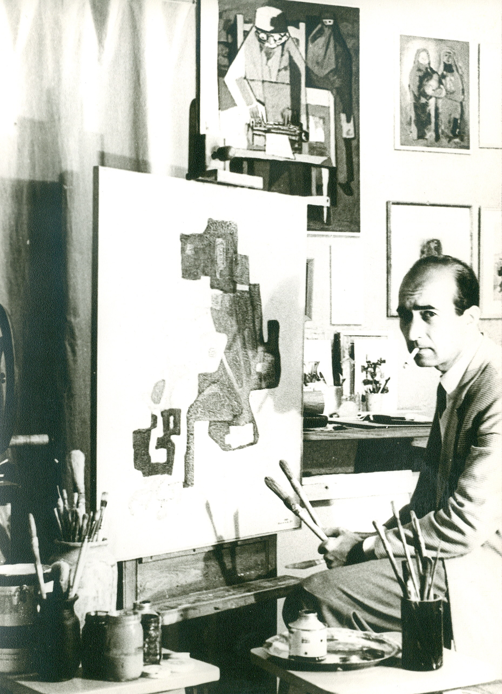

Photograph of Mahmoud Hammad in his studio. *Arabic Writing,* which he exhibited in Aleppo in 1965, is visible on the easel.

Source and copyright: Lubna Hammad, daughter of Mahmoud Hammad. For reproduction rights, please contact Anneka Lenssen ([anneka@berkeley.edu](mailto:anneka@berkeley.edu)) with the needed paperwork, and she will liaise with Lubna Hammad.